Phase 5

Lesson 3

**Delete an EBS Volume**

**Steps :**

1. Selecting the EBS volume you want to delete

2. Deleting the volume

Step 1:

Selecting the EBS volume you want to delete

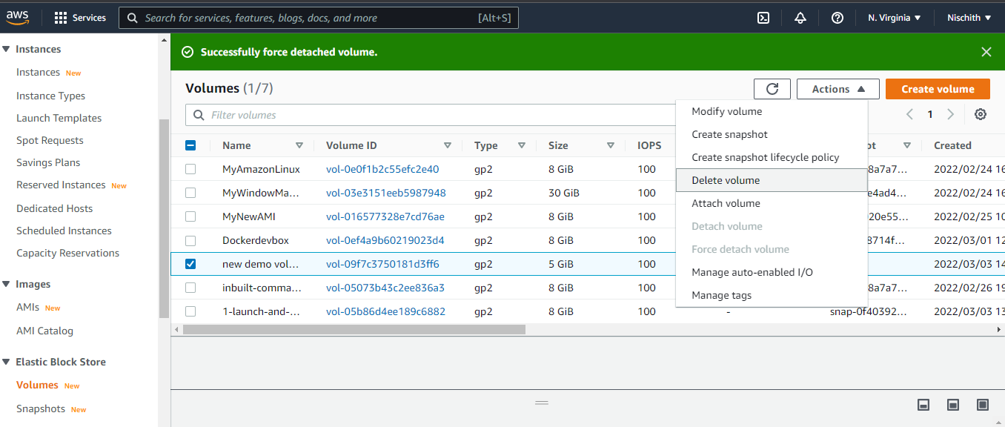

**Step 2:**

Deleting the volume

